Open url <https://topgear.wipro.com>

Give your wipro email id as shown below.

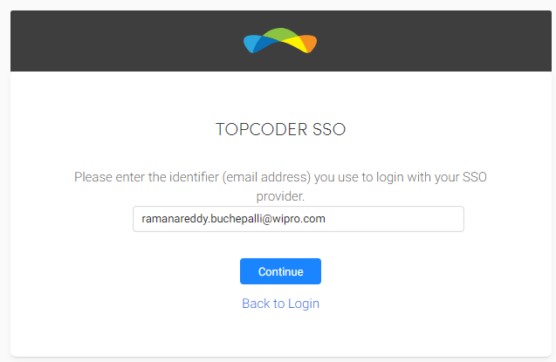

After giving email and click on Continue, pop up window will open like below

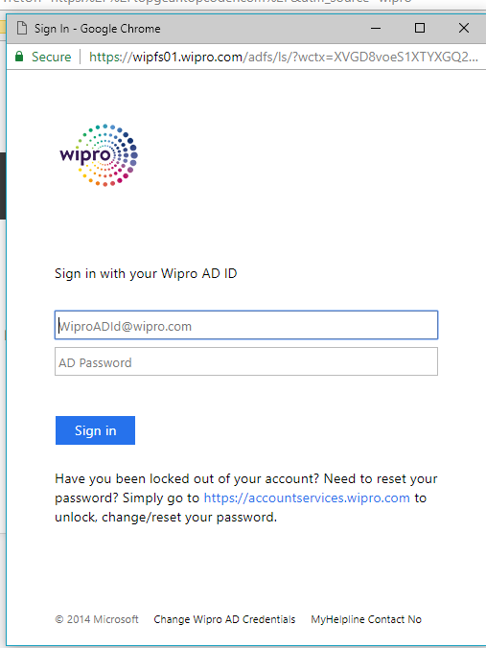

Give your AD ID and password.

After successful login the topgear home page will open like below

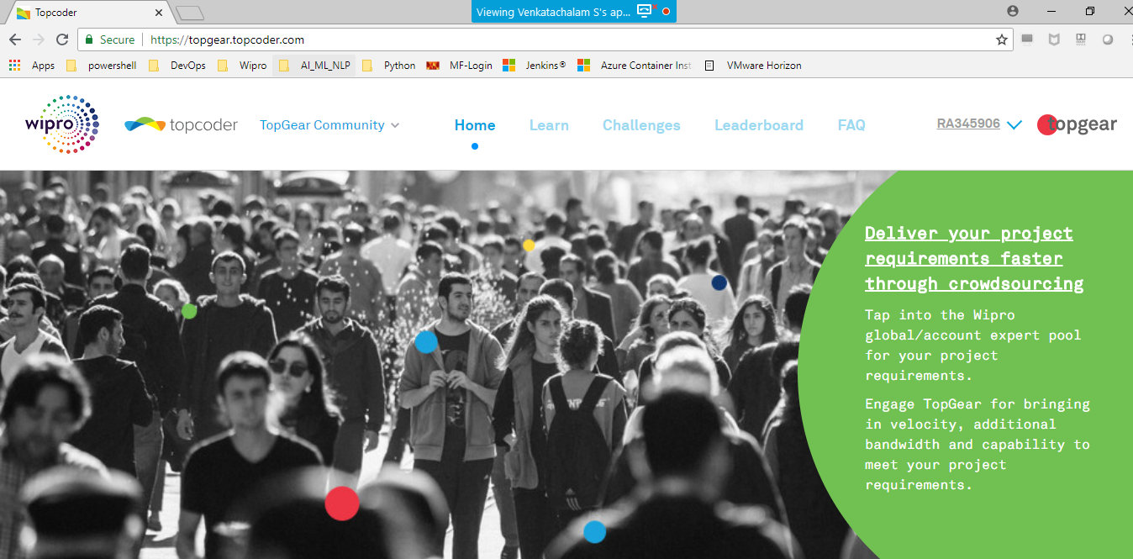

On home page click on “Learn” beside “Home” option

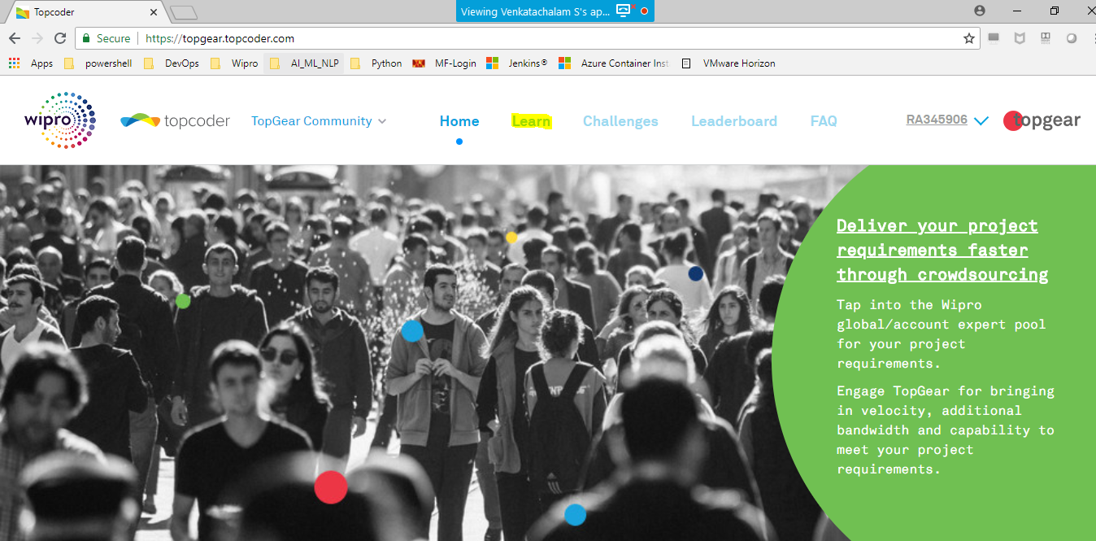

After click on Learn, then new tab will open like below

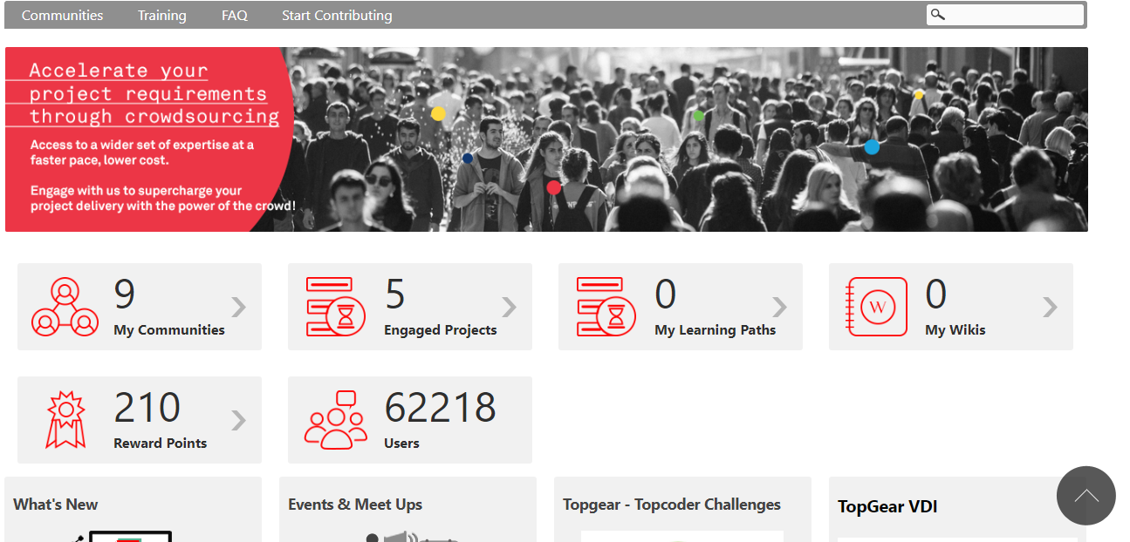

Place your mouse pointer on “Start Contributing” then options will display as shown in below screenshot. Then click on “Request for Dev Environment”.

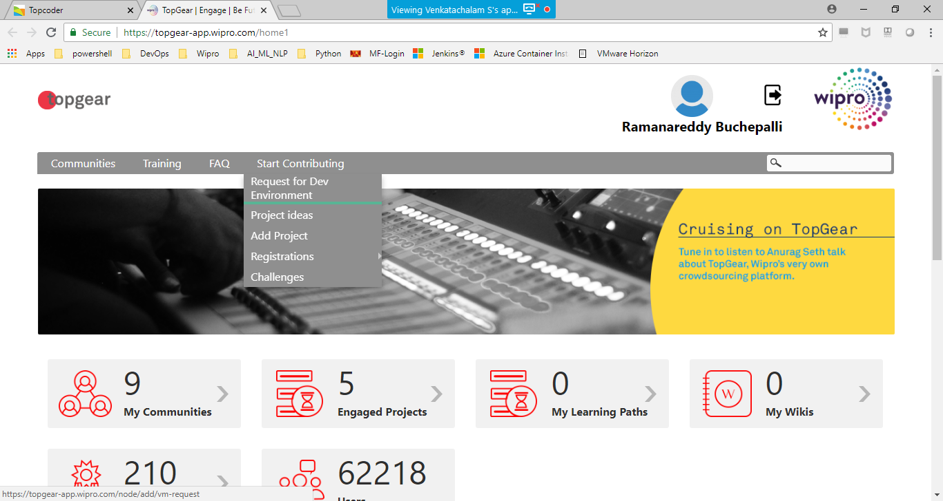

Then below screen will open

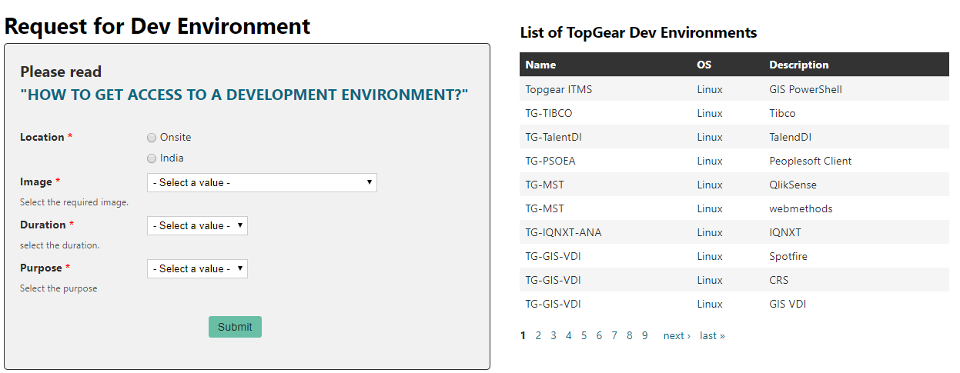

Give the requested details and click on submit. After allocating the VDI for you, you will get mail from topgear.

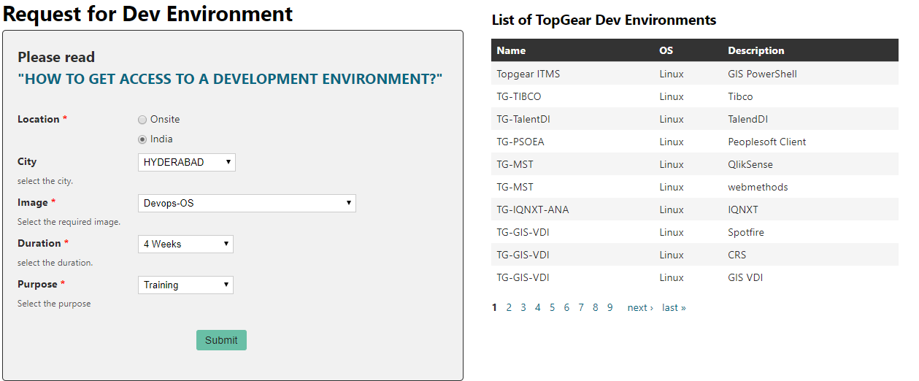

You will get mail from topgear communique as below click on the SOP DOC link in email. So that you will get the details for login to VDI.

